Lab 6 Report

1. **Given a string, calculate next function, print the result out.**
   1. Firstly, for a next_array, the first two elements should be -1 and 0. So I set a list likes: [-1,0,…..,0,0]. I also set 2 int : k and j.

The number j means the location of current element waiting for get a value in the next_array, while the k is used to calculate the that value. While string[j] != string[k], the k = next_array[k] and join the judge again until string[j] == string[k], when next_array[i]=k.

At the end we get a complete next_array.

* 1. Code in Python:

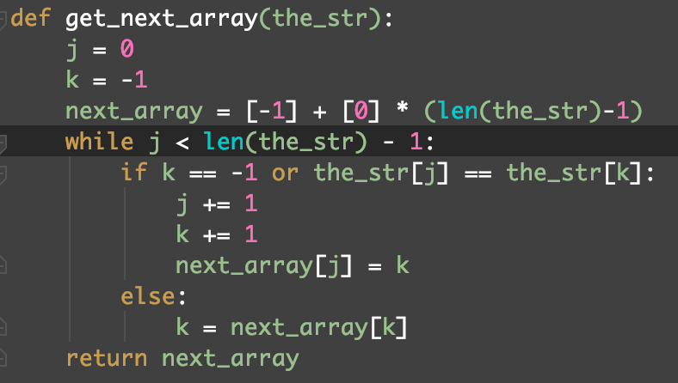

* 1. Test:





1. **Implement KMP algorithm**
   1. Since we have gotten the next_array, while aim_str[i] != model_str[j], I just change the j to next_array[j] until aim_str[i] == model_str[j]. While the j == length of model_str, a copy of model_str in aim_str is found and change the j to (j-1).
   2. Code in Python:

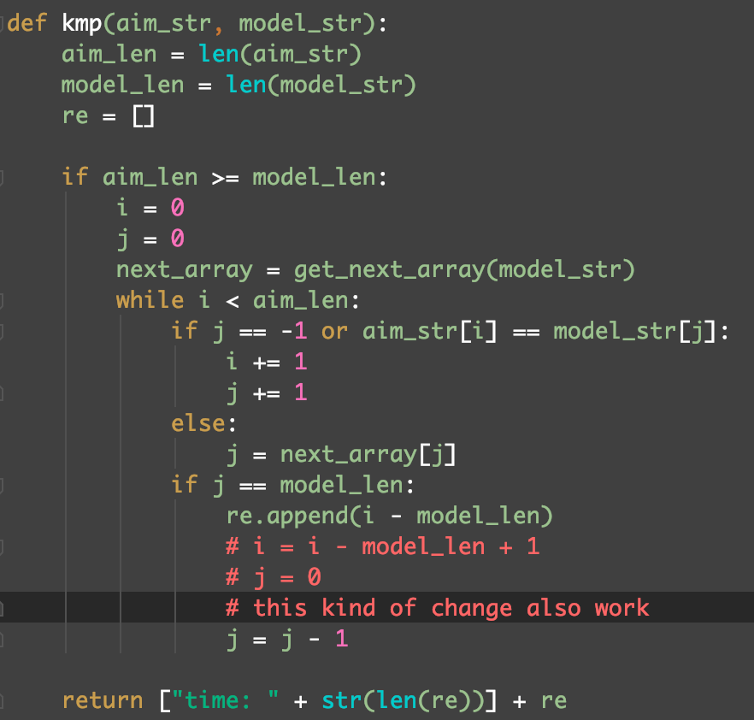

* 1. Test:





1. **Given two strings S1, S2, find out how many time S2 appears in S1. Print out corresponding location when a search is successful.**

S1: ATCGCCGCGATCGTATTTAATCGATTGCATCG

S2: ATCG

Result: ATCGCCGCGATCGTATTTAATCGATTGCATCG

Test:

Output:

